**Wireless Sound Control**

**Project**

**BY**

**Abhishek Raj**

abhirajid[@gmail.com](mailto:imnotharsh14@gmail.com)

**OUTPUT:**

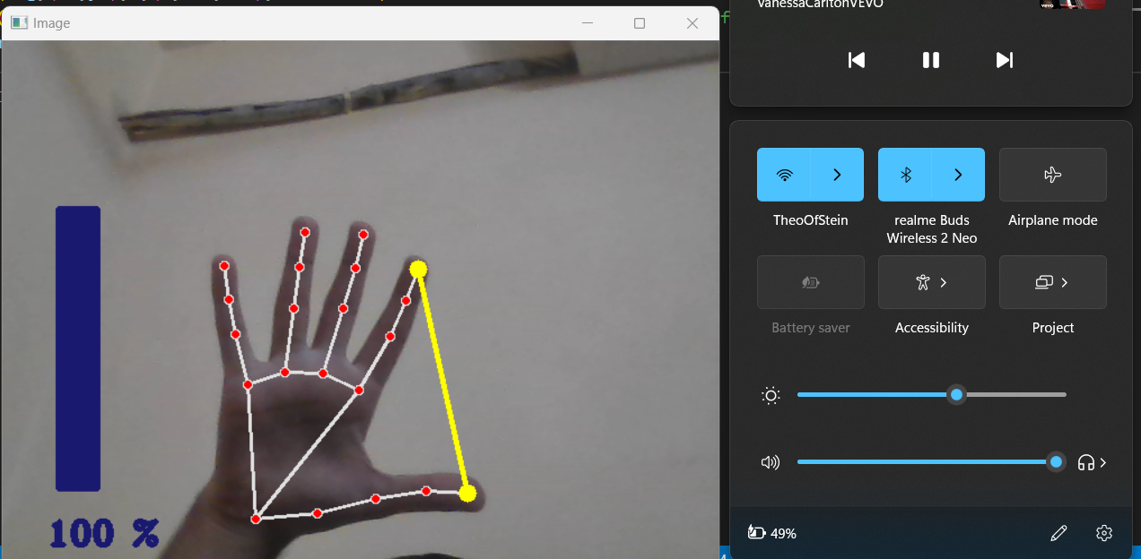

Full length= full volume ,

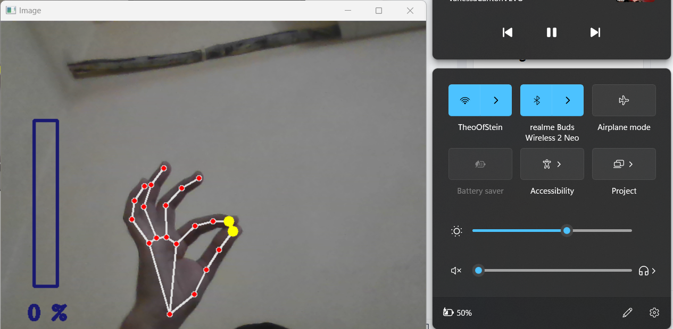

Min length = mute

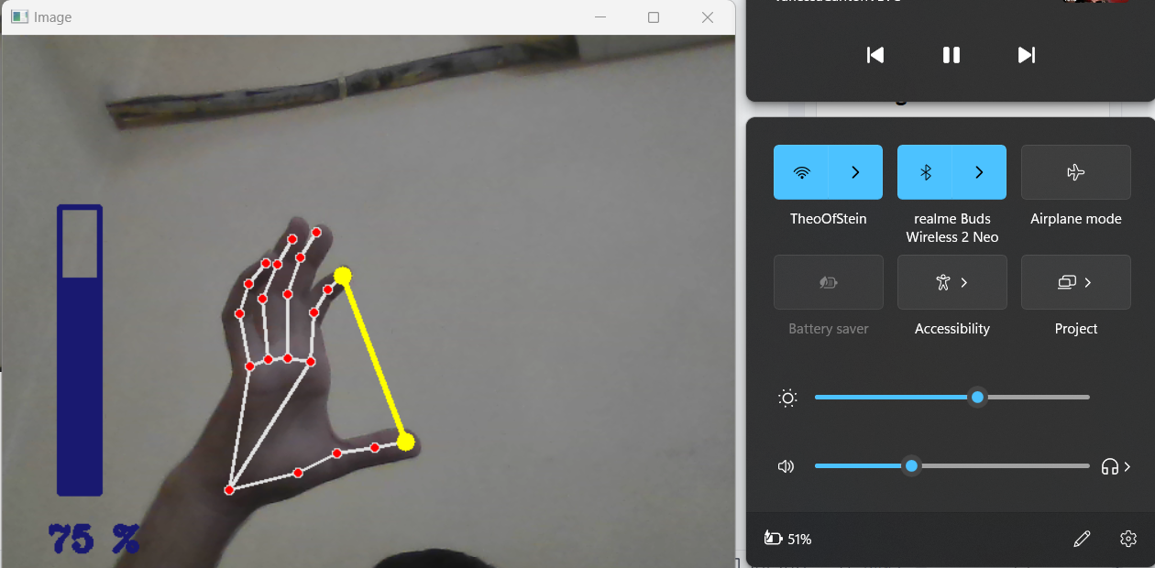

In between 0 and 100 is not smooth and accurate because converting (20,200) to (0,100) does not relate linearly as we need, but is exponential so the volume bar has accelerated increase from around 30% to 100%. I was unable to think of a way to change this linearly. But the basic function does work as expected.